Q1 ) Write a select command that produces the order number, amount, and date for all rows in the Orders table.

KD3_86704_Mayur@>select Onum,Amt,Odate from orders;

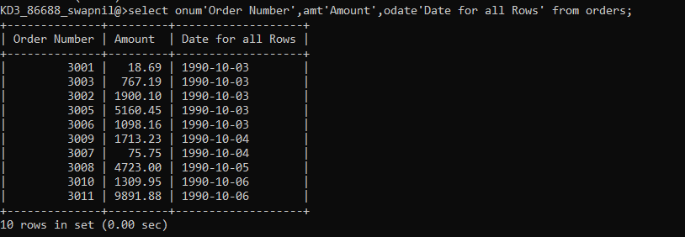

Q2 Write a query that produces all rows from the Customers table for which the salesperson’s number is 1001.

KD3_86704_Mayur@>select * from customers where Snum=1001;

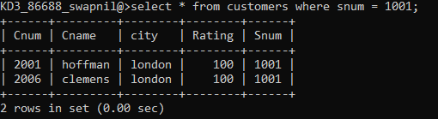

Q3Write a query that displays the Salespeople table with the columns in the following order: city, sname, snum, comm

KD3_86704_Mayur@>select city,Sname,Snum,Comm from salespeople;

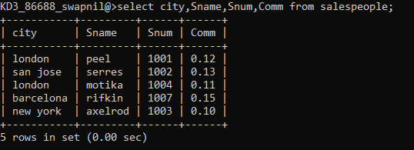

Q4Write a select command that produces the rating followed by the name of each customer in San Jose.

KD3_86704_Mayur@>select Cname, Rating from customers where City="San Jose";

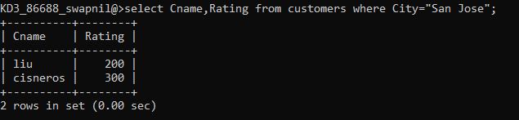

Q5Write a query that will produce the snum values of all salespeople (suppress the duplicates) with orders in the Orders table.

KD3_86704_Mayur@>select distinct Snum from orders order by Snum;

